Project Proposal

For

Super-Market

Submitted by

Mian Muhammad Tayyab, FA21-BSE-041

Muhammad Moiz, FA21-BSE-044

Department of Computer Science, CU, Islamabad.

May 18, 2023

**Table of Contents**

Abstract 2

1. Introduction 2

2. Proposed System 2

3. Advantages/Benefits of Proposed System 3

4. Scope 3

5. Modules 4

5.1 Module 1: Profile Management: 4

5.2 Module 2: Product Management: 4

5.3 Module 3: Order Management 4

5.4 Module 4: Delivery Management 4

5.5 Module 5: Category Management 4

5.6 Module 6: Query Management 5

6. System Limitations/Constraints 5

7. Tools and Technologies 5

8. Conclusion 6

9. References 6

**Project Category: (**Select the major domain of proposed project**)**

* **A-**Desktop Application/Information System

# Abstract

This system is a web-based application that will help super market owner to sell their products online and customers can purchase those products online. This will increase the ease of access for the users when it comes to buying products and it will help Super-Market owner to extend their business with the aid of database and other computer technologies. This system will use database to store and retrieve data for the user which makes it faster and efficient and reliable to use and information also remains stored for long periods of times without the chance of data loss.

# Introduction

This system helps improve the current manual system of shopping in which a person has to physically go to the store to purchase products which can take a substantial amount of time and resources like transport. It is also very inconvenient to go shopping for stuff during this pandemic because of the lockdowns. The proposed system will completely replace or aid the current shopping methods by an online one through which anyone can order anything without the need to get out of their home which will be especially useful for people during these times and also in the future it will just remove all the time it takes to go shopping and people can order anything at any point with a few clicks.

# Proposed System

The proposed system will be a desktop application that will help admins sell and manage their products on it and the customers will be able to buy those products using the same application. All the products added by the admin will be stored in the database and when the customer uses the application that data will be fetched from the database and displayed to the customer. Admins will be able to manage their employees using the system. Everything the user may need to shop products from home will be provided by the application for an overall efficient way of buying products from home which will not only reduce human effort but also help saving lives because it will lessen the amount of people getting out of their home and shopping during the pandemic. The proposed system also focuses on providing the best user experience so the customer and employees using the system can relay their queries directly to the admin using built in features.

# Advantages/Benefits of Proposed System

* Increase the comfort of users by allowing them to shop for products from home
* Reduce the transport charges and problems that occur while going for manual shopping
* Reduce the human effort and time consumption
* Its easier for administrators to keep track of what customers are buying and which products need to be added or changed
* Customers can keep track of when their items will be delivered
* Customers don’t have to wait in long lines to checkout and employees don’t have to scan each item to get its price it will be all done automatically by the system
* Employees can easily check which items are low in stock and add them
* All the data will be stored in the database so in case of any issues it can be retrieved and verified

# Scope

The main goal of the proposed system is to make shopping products as easier and efficient as possible and convenient for both users and owners. The system will have three types of users Admin, employee and customer. Every user will have to register or login before using the application with their own unique username and passwords. Admin can add new products to different categories and also remove products. Admin can manage the employees and also fire them if he/she likes. Employees will be able to Manage stock and also confirm orders so that they are delivered to the Customers. Customers will be able to browse the different categories and add products in their cart and when they are done, they can checkout and a table will be shown to them of the items they selected and the amount and price of that item. Customer can remove items from cart or place order which will then be delivered to them after one of the employees confirms. Customers can also cancel their orders if it has not been delivered yet.

# Modules

The modules of this project are divided into six major categories based on the functionalities they provide and each of them is discussed briefly as follows:

## Module 1: Profile Management:

This module provides users the ability to have their own profiles through which they can login and use the application. In this way each user has their own private account and their own saved data which can only be accessed by a username and password. This provides security to the user and also allows multiple users to use the app without any interference with each other.

### Register: User provide their info to create a new account.

### Login: User can login to their account using username and password

## Module 2: Product Management:

This module will be used by different users to change product details. Admin will be able to add new products and all of its information and can also view and delete the added products using this module. Admin can also edit product details like its name, picture, price etc. Employees can also view the product and change the stock. All the Product related details are managed using this module in all the user categories. All the data will be stored in the database and will be displayed to the user in table forms.

## Module 3: Order Management

This module is for all the information related to Orders. It will be used to manage customer’s interaction with the system like adding items to cart and if the item is out of stock user will be notified and Customer can also select multiple items and go to checkout menu where the customer can see order details and total price of the order. Customer can either place the order or delete items from the cart or cancel everything. Once the order is placed user can also cancel the order if it has not been delivered yet.

## Module 4: Delivery Management

This module will help the users in the delivery process of the system. Once the customers have placed orders, they will be pending for employees to approve and employees can approve orders and view the details of the order and once approved the items will be delivered to the customer. Customers can check the status of their order from their menu it will show if the items are delivered or still pending approval from the employee. Customers can only cancel the orders that have not been approved for delivery yet.

## Module 5: Category Management

This module will aid the system in various ways. It includes the category part of the system from which the users can select which category to choose. Every user has to choose a category when trying to view the products. Admin will have to choose product category when adding new products and employees will have to choose it when adding new stock. Each category will have its own unique items which will be different from other categories. Customers will choose the category when trying to buy products and for each category customer will be shown different types of products.

## Module 6: Query Management

This module will help all the users to resolve any query or complain they have with the admin or the user who is high in command to them. This module will help make the system more user friendly. Employees will be able to send complains to the admin and Admin will be able see the queries from the employees, Customers can file complains to the employees which can be seen by all the employees in their profile menus. This will help users communicate with each other to resolve issues that may occur during the use of the system.

# System Limitations/Constraints

* Customer cannot physically touch the item which can sometimes be very useful when buying products physically in checking the quality of the item
* Delivery may take several days which can be inconvenient for some people if they need the items asap.
* Customers may have to pay extra delivery charges depending on how far the store is.

# Tools and Technologies

Table 1 Tools and Technologies for Proposed Project

|  |  |  |  |
| --- | --- | --- | --- |
| **Tools**  **And**  **Technologies** | **Tools** | **Version** | **Rationale** |
| IntelliJ | 2022 | IDE |
| MongoDB Compass Server | 2012 | DBMS |
| MS Word | 2019 | Documentation |
| **Technology** | **Version** | **Rationale** |
| Java | 17 | Programming language |
| NoSQL | 20.4.1 | Query Language |
| Swing | - | API for java |
|  | Data modeler | 21.1 | ERD maker for MySQL |

# Conclusion

Overall, this system will help in reducing the human efforts and resources when It comes to shopping and also reduce the time consumed for this process. Customers can use this system at any time of the day and also get benefit from its various features. Although the system might be difficult to implement fully it will increase convenience and quality of life.

# References

* *The Future of Shopping*. (2014, October 8). Harvard Business Review. <https://hbr.org/2011/12/the-future-of-shopping>

# ERD

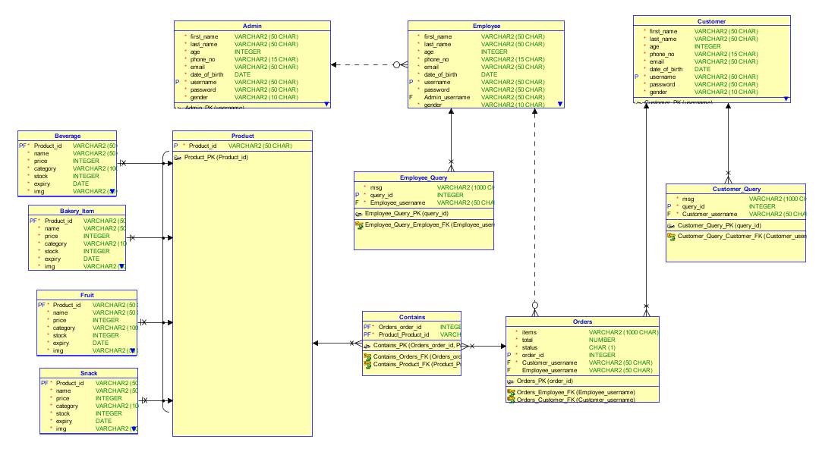



# JSON Script

Admin:

{

"FIRST_NAME": "Muhammad",

"LAST_NAME": "Tayyab",

"AGE": 20,

"PHONE_NO": "+92 3487726606",

"EMAIL": "tayyabm708@gmail.com",

"DATE_OF_BIRTH": "23-Dec-03",

"USERNAME": "tayyabm708",

"PASSWORD": "1234",

"GENDER": "Male"

}

Customer:

{

"FIRST_NAME": "Moiz",

"LAST_NAME": "Khan",

"AGE": 20,

"PHONE_NO": "+92 3339874875",

"EMAIL": "moiz@gmail.com",

"DATE_OF_BIRTH": "10-FEB-97",

"USERNAME": "Moiz86",

"PASSWORD": "1234",

"GENDER": "Male"

}

Customer_Query:

{

"MSG": "yea yea uh whatever",

"QUERY_ID": 1,

"CUSTOMER_USERNAME": "Moiz86"

}

Employee:

[{

"FIRST_NAME": "Ifra",

"LAST_NAME": "Batool",

"AGE": 20,

"PHONE_NO": "+92 3239874225",

"EMAIL": "ifra@gmail.com",

"DATE_OF_BIRTH": "20-NOV-99",

"USERNAME": "Batool86",

"PASSWORD": "1234",

"ADMIN_USERNAME": null,

"GENDER": "Female"

},

{

"FIRST_NAME": "Ayyan",

"LAST_NAME": "Javed",

"AGE": 20,

"PHONE_NO": "+92 3239874225",

"EMAIL": "ayyan@gmail.com",

"DATE_OF_BIRTH": "20-NOV-99",

"USERNAME": "Ayyab86",

"PASSWORD": "1234",

"ADMIN_USERNAME": null,

"GENDER": "Female"

}

]

Employee_Query:

[

{

"MSG": "my complain is that you dont smile :)",

"QUERY_ID": 1,

"EMPLOYEE_USERNAME": "Batool86"

},

{

"MSG": "also dont be sad :>",

"QUERY_ID": 2,

"EMPLOYEE_USERNAME": "Batool86"

}

]

[{

"_id": {

"$oid": "647ae642743803d058cafe88"

},

"PRODUCT_ID": "cc",

"NAME": "Cocomo",

"PRICE": 10,

"CATEGORY": "Snacks",

"STOCK": 81,

"EXPIRY": "01-JAN-23",

"IMG": "Images\\Cocomo.png"

},

{

"_id": {

"$oid": "647ae642743803d058cafe89"

},

"PRODUCT_ID": "bb",

"NAME": "Bunties",

"PRICE": 6,

"CATEGORY": "Snacks",

"STOCK": 68,

"EXPIRY": "02-APR-21",

"IMG": "Images\\bunty.png"

},

{

"_id": {

"$oid": "647ae642743803d058cafe8a"

},

"PRODUCT_ID": "pp",

"NAME": "Pringles",

"PRICE": 130,

"CATEGORY": "Snacks",

"STOCK": 59,

"EXPIRY": "16-MAY-25",

"IMG": "Images\\pringles.png"

},

{

"_id": {

"$oid": "647ae69a743803d058cafe8c"

},

"PRODUCT_ID": "choco",

"NAME": "Dairy Milk",

"PRICE": 20,

"CATEGORY": "Snacks",

"STOCK": 59,

"EXPIRY": "03-OCT-23",

"IMG": "Images\\dairymilk.png"

},

{

"_id": {

"$oid": "647ae69a743803d058cafe8d"

},

"PRODUCT_ID": "dor",

"NAME": "Doritos",

"PRICE": 40,

"CATEGORY": "Snacks",

"STOCK": 160,

"EXPIRY": "07-DEC-25",

"IMG": "Images\\doritos.png"

},

{

"_id": {

"$oid": "647ae69a743803d058cafe8e"

},

"PRODUCT_ID": "ll",

"NAME": "Lays",

"PRICE": 30,

"CATEGORY": "Snacks",

"STOCK": 197,

"EXPIRY": "23-MAR-23",

"IMG": "Images\\lays.png"

},

{

"_id": {

"$oid": "647ae6bc743803d058cafe94"

},

"PRODUCT_ID": "ww",

"NAME": " Nestle Water 250mg",

"PRICE": 60,

"CATEGORY": "Beverages",

"STOCK": 45,

"EXPIRY": "07-DEC-25",

"IMG": "Images\\water.png"

},

{

"_id": {

"$oid": "647ae6bc743803d058cafe95"

},

"PRODUCT_ID": "jj",

"NAME": "Nestle Juice",

"PRICE": 90,

"CATEGORY": "Beverages",

"STOCK": 80,

"EXPIRY": "23-MAR-23",

"IMG": "Images\\juice.png"

},

{

"_id": {

"$oid": "647ae6bc743803d058cafe96"

},

"PRODUCT_ID": "ss",

"NAME": "Sprite 500mg",

"PRICE": 55,

"CATEGORY": "Beverages",

"STOCK": 18,

"EXPIRY": "16-MAY-25",

"IMG": "Images\\sprite.png"

},

{

"_id": {

"$oid": "647ae6e0743803d058cafe98"

},

"PRODUCT_ID": "aa",

"NAME": "Apple",

"PRICE": 40,

"CATEGORY": "Fruits & Vegetables",

"STOCK": 78,

"EXPIRY": "03-AUG-21",

"IMG": "Images\\apple.png"

},

{

"_id": {

"$oid": "647ae6e0743803d058cafe99"

},

"PRODUCT_ID": "cap",

"NAME": "Capsicum",

"PRICE": 15,

"CATEGORY": "Fruits & Vegetables",

"STOCK": 120,

"EXPIRY": "03-SEP-21",

"IMG": "Images\\capsi.png"

},

{

"_id": {

"$oid": "647ae6e0743803d058cafe9a"

},

"PRODUCT_ID": "let",

"NAME": "Lettuce",

"PRICE": 20,

"CATEGORY": "Fruits & Vegetables",

"STOCK": 79,

"EXPIRY": "09-AUG-24",

"IMG": "Images\\lettuce.png"

},

{

"_id": {

"$oid": "647ae6e0743803d058cafe9b"

},

"PRODUCT_ID": "mm",

"NAME": "Mango",

"PRICE": 50,

"CATEGORY": "Fruits & Vegetables",

"STOCK": 512,

"EXPIRY": "03-OCT-23",

"IMG": "Images\\mango.png"

},

{

"_id": {

"$oid": "647ae6e0743803d058cafe9c"

},

"PRODUCT_ID": "Oo",

"NAME": "Orange",

"PRICE": 25,

"CATEGORY": "Fruits & Vegetables",

"STOCK": 40,

"EXPIRY": "06-DEC-22",

"IMG": "Images\\orange.png"

},

{

"_id": {

"$oid": "647ae70a743803d058cafe9e"

},

"PRODUCT_ID": "ee",

"NAME": "One Dozen Eggs",

"PRICE": 200,

"CATEGORY": "Bakery Items",

"STOCK": 20,

"EXPIRY": "03-OCT-23",

"IMG": "Images\\egg.png"

},

{

"_id": {

"$oid": "647ae70a743803d058cafe9f"

},

"PRODUCT_ID": "rr",

"NAME": "Rusk",

"PRICE": 70,

"CATEGORY": "Bakery Items",

"STOCK": 40,

"EXPIRY": "07-DEC-25",

"IMG": "Images\\rusk.png"

},

{

"_id": {

"$oid": "647ae70a743803d058cafea0"

},

"PRODUCT_ID": "cook",

"NAME": "Cookie",

"PRICE": 20,

"CATEGORY": "Bakery Items",

"STOCK": 80,

"EXPIRY": "23-MAR-23",

"IMG": "Images\\Cookie.png"

},

{

"_id": {

"$oid": "647af15edd4ed8107bfb6f4f"

},

"PRODUCT_ID": "chups",

"NAME": "Chupa Chups",

"PRICE": 50,

"CATEGORY": "Snacks",

"STOCK": 74,

"EXPIRY": "2026-6-11",

"IMG": "Images\\default.png"

},

{

"_id": {

"$oid": "647b0d65743803d058cafea9"

},

"PRODUCT_ID": "kala",

"NAME": "Coke Can",

"PRICE": 35,

"CATEGORY": "Beverages",

"STOCK": 48,

"EXPIRY": "03-OCT-23",

"IMG": "Images\\Coke.png"

}]

Orders:

[

{

"ITEMS": "Pringles, Dairy Milk, Cocomo, Lays",

"TOTAL": 290,

"STATUS": "0",

"ORDER_ID": 2,

"CUSTOMER_USERNAME": "customer",

"EMPLOYEE_USERNAME": null

},

{

"ITEMS": "Apple, Mango, Lettuce",

"TOTAL": 300,

"STATUS": "1",

"ORDER_ID": 3,

"CUSTOMER_USERNAME": "customer",

"EMPLOYEE_USERNAME": null

}

]